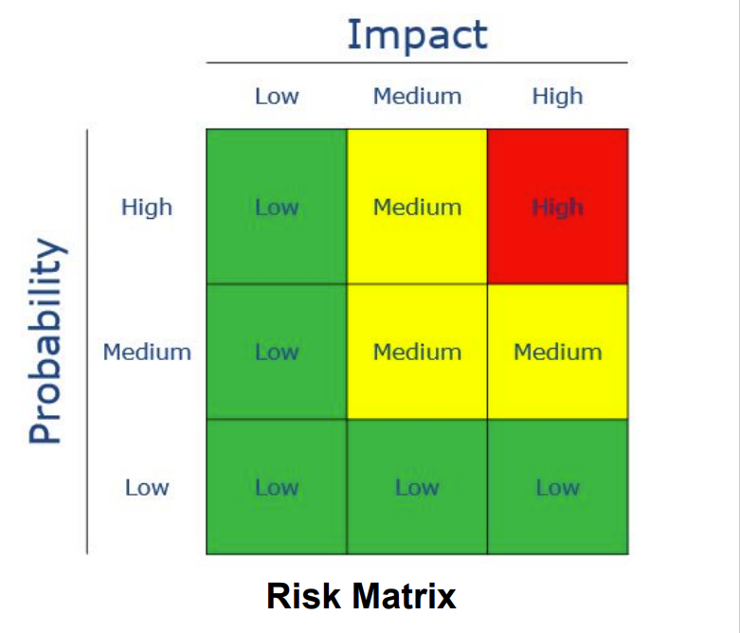

| ID | Date Raised | Risk Description | Likelihood of the risk occurring | Impact to the project | Severity | Mitigating Action | Contingency Plan |
| --- | --- | --- | --- | --- | --- | --- | --- |
| 1 | 13/08/2024 | Mental Health Crisis  When a team member experiences a severe mental health crisis, such as a mental breakdown or intense pressure | LOW | This could affect team productivity, lead to delays in task completion, and potentially cause a decrease in overall project quality | Low | * Encourage consultation sessions with Teaching Assistants * completing work on time to avoid built up stress towards the deadline. * Have a supportive environment that allows team members to have open discussion about their workload and stress level. | * Provide support by offloading some of their tasks and responsibilities * Redistribute the affected member’s task to other group mates equally. |
| 2 | 13/08/2024 | Personal Issues  When a team member receives distressing news or faces personal challenges that significantly affect their ability to focus and work efficiently. | LOW | Team member's efficiency might decrease significantly, leading to delays in their assigned tasks, which could impact the project timeline. | Low | * Allow flexibility in work hours to accommodate personal circumstances. * Regularly check in on team members to offer support and understand if any personal issues are affecting their work. | * Redistribute the affected member’s task to other group mates equally. * Offer support by having bonding sessions as a team to ensure team members feel valued and supported. |
| 3 | 13/08/2024 | Technical debt  Accumulation of shortcuts, incomplete implementation and substandard code that will affect the quality of the product in the long run. | MEDIUM | Accumulating technical debt can lead to future maintenance challenges, increased debugging time, and potential delays in project delivery due to unforeseen technical issues. | MEDIUM | * Follow good programming principles and practices, create branches in GIT for backup and avoid hardcoding. * Have code review sessions as a team, so feedback can be provided and ensure high code quality | * In case of critical technical debt issues, always prioritise refactoring over developing new features. * Reassign task among members to focus on minimising technical debt |
| 4 | 13/08/2024 | Technical issue  Unexpected problems with software, hardware, or network systems. (e.g system crashes, software bugs, hardware failures, or connectivity problems…) | MEDIUM | Critical errors in team members' devices could result in lost work, decreased productivity, and potential delays in project timelines. | MEDIUM | * Run diagnosis on the computer to identify any potential problem in your device. * Ensure team members regularly backup files and data * Update and ensure software and systems are up to date. * Have an alternative hardware or backup systems | * Switch to an alternative hardware or backup systems to continue working * Seek for IT support immediately * If a software is down, identify the next best alternative to continue working temporary |
| 5 | 20/08/2024 | Miscommunications between members  Misunderstandings or lack of clear communication between team members that can occur due to unclear instructions, assumptions, or failure to share important information. | MEDIUM | Lead to misunderstandings regarding tasks and requirements, resulting in errors, rework, and inefficiencies that can delay the project. | MEDIUM | * Ask for clarification between members. Write everything down in black and white. * Schedule daily stand ups to keep everyone informed about project progress, tasks, and any changes. | * address it immediately by clarifying the issue with all involved members. * facilitate a resolution through open discussion or involve a mediator, such as the project manager, to help resolve the issue. |
| 7 | 20/08/2024 | Project purpose is undefined  Team member are unable to make a clear purpose when they are making the project | LOW | An unclear project purpose can lead to confusion among team members, misaligned efforts, and ultimately a product that does not meet client expectations, risking project failure. | LOW | Talk with the client and seek more information. |  |
| 8 | 20/08/2024 | Accident  Team member gets into a non-fatal car accident. | LOW | A team member’s involvement in a non-fatal accident could result in their temporary absence, affecting the team's capacity and potentially causing delays. | LOW | Encourage safe practices and avoid unsafe/risky circumstances. | * Redistribute the affected member’s task to other group mates equally. |
| 9 | 20/08/2024 | Mild disease  Team member contracts a mild disease (e.g common cold) | LOW | could lead to temporary reduced productivity or absence, impacting the project timeline. | LOW | Maintain good personal hygiene, encourage a good work-life balance | * Redistribute the affected member’s task to other group mates equally. |
| 10 | 20/08/2024 | Conflicting client’s requirements. (what we received and client’s imagination is different)  A situation where the requirements provided by the client differ from what the client actually envisions or expects. | MEDIUM | Differences between client expectations and delivered work can lead to significant rework, increased costs, and potential delays in project delivery. | MEDIUM | * Consult with the client and show them the prototype.Obtain formal approval from the client to ensure alignment. * Implement regular feedback loops with the client throughout the project to ensure that their expectations are being met * Maintain clear and detailed documentation of all requirements and client communications. | * schedule an immediate meeting with the client to discuss and reconcile the differences. |
| 11 | 21/08/2024 | The team might accidentally infringe on copyrights or patents, leading to legal disputes. | MEDIUM | Legal disputes from accidental infringement could result in project delays, increased legal costs, and damage to the project's reputation. | MEDIUM | Educate team members on intellectual property laws and the importance of originality in work. |  |